Math 231 Test #1

Your Name:

Please circle your discussion group (1 pt)

|  |  |  |
| --- | --- | --- |
| 1 Yang Yihong A410 | 4 Zhang Junwei A404 | 7 Liu Yuanzhe A424 |
| 2 Xu Yixiao A425 | 5 Liang Jun A408 | 8 Jaden Peterson Wen A421 |
| 3 Dai Ruiqi A426 | 6 She Yuxuan A423 |  |

* No notes, books or electronics during the exam.
* Do not open this test booklet until a proctor says start.
* For all free response questions, show work that justifies your answer.
* Raise your hand if you have a clarification question.
* Scratch paper is provided. You can ask for more if needed.
* Do not leave early: this disturbs others. If you finish your test early, check your work

or just relax.

* Quit working when the test ends and hand your test booklet to proctors.

1. (15 points, 3 points each) Determine whether the statement is true or false. Circle the right answer.
2. Suppose $f$ and $g$ are continuous on $[a, ∞)$ and $f\left(x\right)≥g(x)$, if $\int_{0}^{∞}{f(x)dx}$ is convergent, then $\int_{0}^{∞}{g\left(x\right)dx}$ is convergent. (True or False)
3. Approximate integration is a numerical method to calculate the value of definite integral. (True or False)
4. $3s=e^{t}+e^{t}\frac{ds}{dt}$ is a linear differential equation. (True or False)
5. The areas of two regions are the same in the first quadrant of $xy$ plane, if we rotate them about $x$ axis, the volumes we get must be the same. (True or False)
6. $\int_{0}^{2}{\frac{dx}{{\left(x-1\right)}^{2}}=-2}$ (True or False)

|  |  |  |  |  |  |  |  |  |  |  |
| --- | --- | --- | --- | --- | --- | --- | --- | --- | --- | --- |
| Question | 1 | 2 | 3 | 4 | 5 | 6 | 7 | 8 | 9 | Total |
| Points | 15 | 10 | 10 | 10 | 8 | 10 | 10 | 14 | 12 | 99 |
| Score |  |  |  |  |  |  |  |  |  |  |

1. (10 points) If $\int_{0}^{π/4}{\tan^{6}{x}}\sec{x}=I$, express the value of $\int_{0}^{π/4}{\tan^{8}{x}}\sec{x}dx$ in terms of $I$.

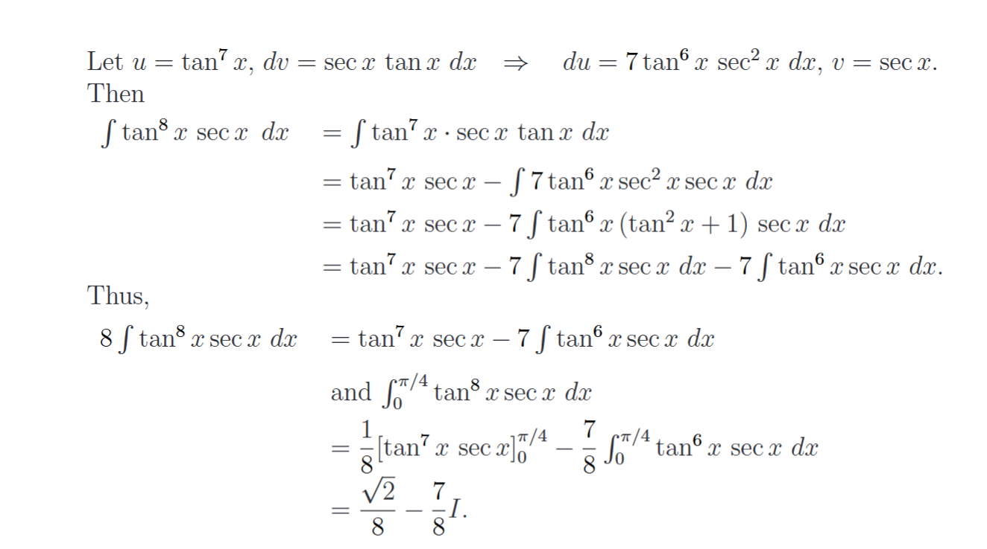

1. (10 points) Evaluate the following integral

$$\int{\frac{x+5}{x^{2}-6x+13}dx}$$

$$=\frac{1}{2}\int{\frac{2x-6}{x^{2}-6x+13}dx+\int{\frac{8}{x^{2}-6x+13}dx}}$$

$$\frac{1}{2}\int{\frac{1}{x^{2}-6x+13}d(x^{2}-6x+13)+\int{\frac{8}{{\left(x-3\right)}^{2}+4}dx}}$$

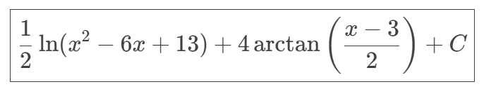

1. (10 points) If $a≠0$ and $n$ is a positive integer, find the partial fraction decomposition of $f\left(x\right)=\frac{1}{x^{n}\left(x-a\right)}$.and calculate the coefficient.

Hint: first find the coefficient of $\frac{1}{x-a}$. Then subtract the resulting term and simplify what is left.

$$x^{n}-a^{n}=(x-a)(x^{n-1}+x^{n-2}a+x^{n-3}a^{2}+…+xa^{n-2}+a^{n-1})$$

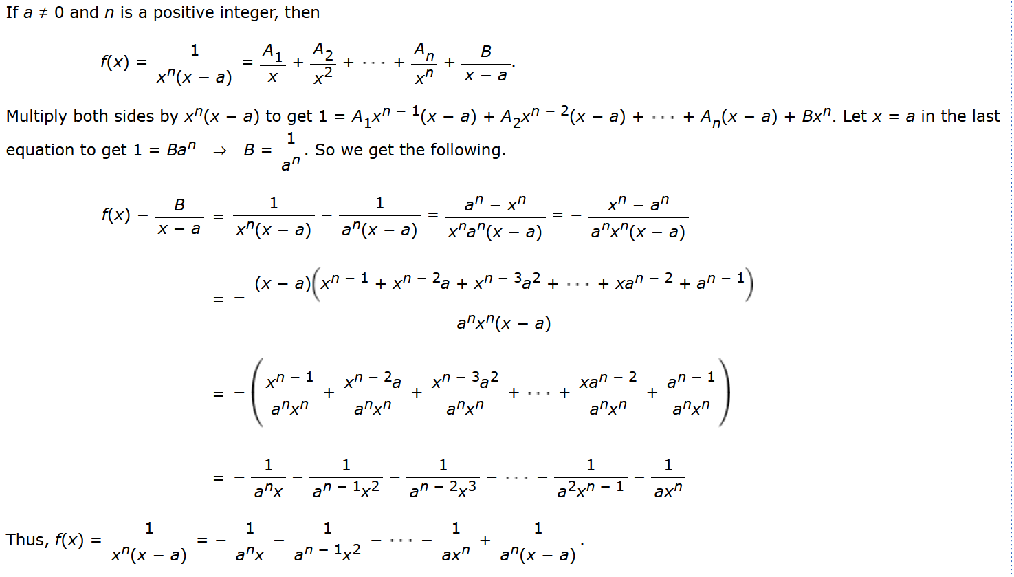

1. (8 points) Determine whether the integral is convergent or divergent.

(a) $\int_{3}^{∞}{\frac{x^{3}}{x^{3}+e^{x}+\cos^{2}{x}}dx}$

* Convergent
* Divergent

(b) $\int_{0}^{1}{\frac{\sin{x}}{\sqrt{x}}dx}$

* Convergent
* Divergent

1. (10 points) Consider the region $S$ bounded by the curves $y=x+\frac{1}{x^{2}}$ and $y=x-\frac{1}{x^{2}}$ for $x≥1.$

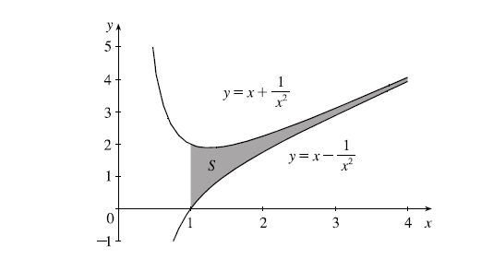

(a) Is the area of $S$ finite or infinite? If finite, find the area.

(b) Now suppose we retate $S$ around the $x$ axis. Is the volume of the resulting solid finite or infinite?

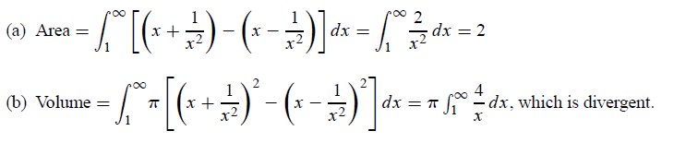

1. (10 points) Let $R$ be the region shaded below. Find the coordinates of the centroid of .

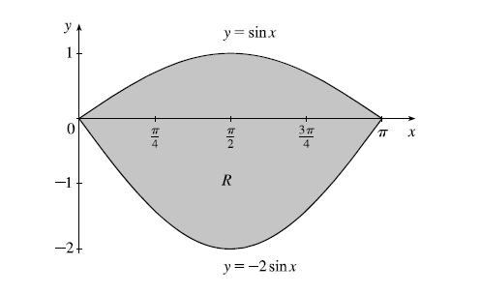

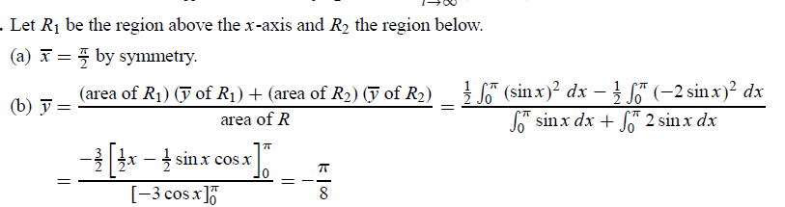

8. (14 points) $y=1-e^{-x}, 0≤x≤2$, find the exact arc length for this function.

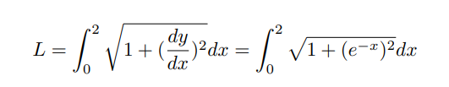

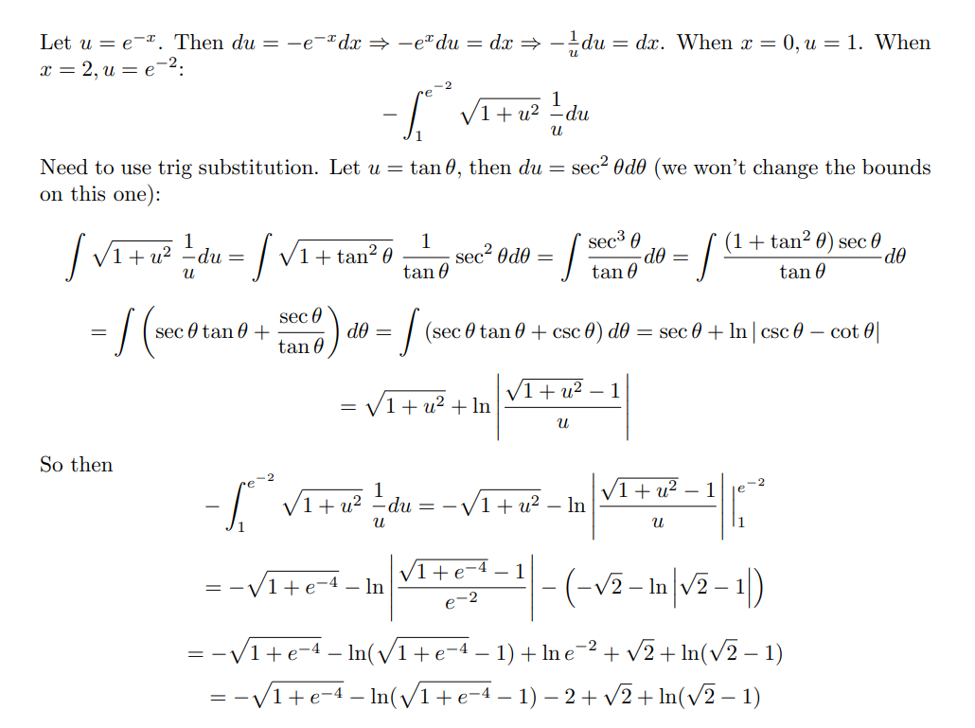

9. (12 points) Solve the differential equation.

(a)

$$\frac{dz}{dt}+e^{t+z}=0$$

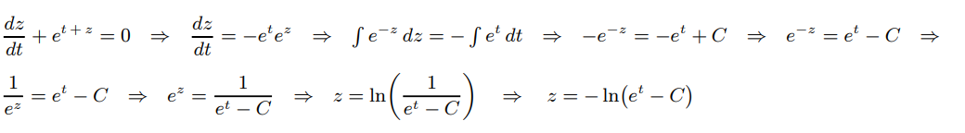

(b) $y^{'}=x-y$

